Smart Welding Helmet using ThingSpeak
Introduction
A Smart welding helmet has been developed to monitor the environmental conditions of welders by utilizing ThingSpeak. Within fabrication industries, welders commonly operate in confined spaces with inadequate ventilation, leading to the exposure to unfavourable surroundings. Hence, the helmet consistently monitors air quality, temperature, and gas leakage levels.
Development
The implementation of this project involves employing a Raspberry Pi Pico microcontroller along with the programming tool Thonny. Additionally, the system integrates a MQ-2 sensor, MQ-135 sensor, and a TMP36 temperature sensor for data acquisition. The raspberry pi Pico, MQ-2 and MQ-135 sensors were enclosed in 3d printed cases. The 3d printed cases are modded versions of Thingiverse.com ,2018 a and Thingiverse.com , 2018 b.
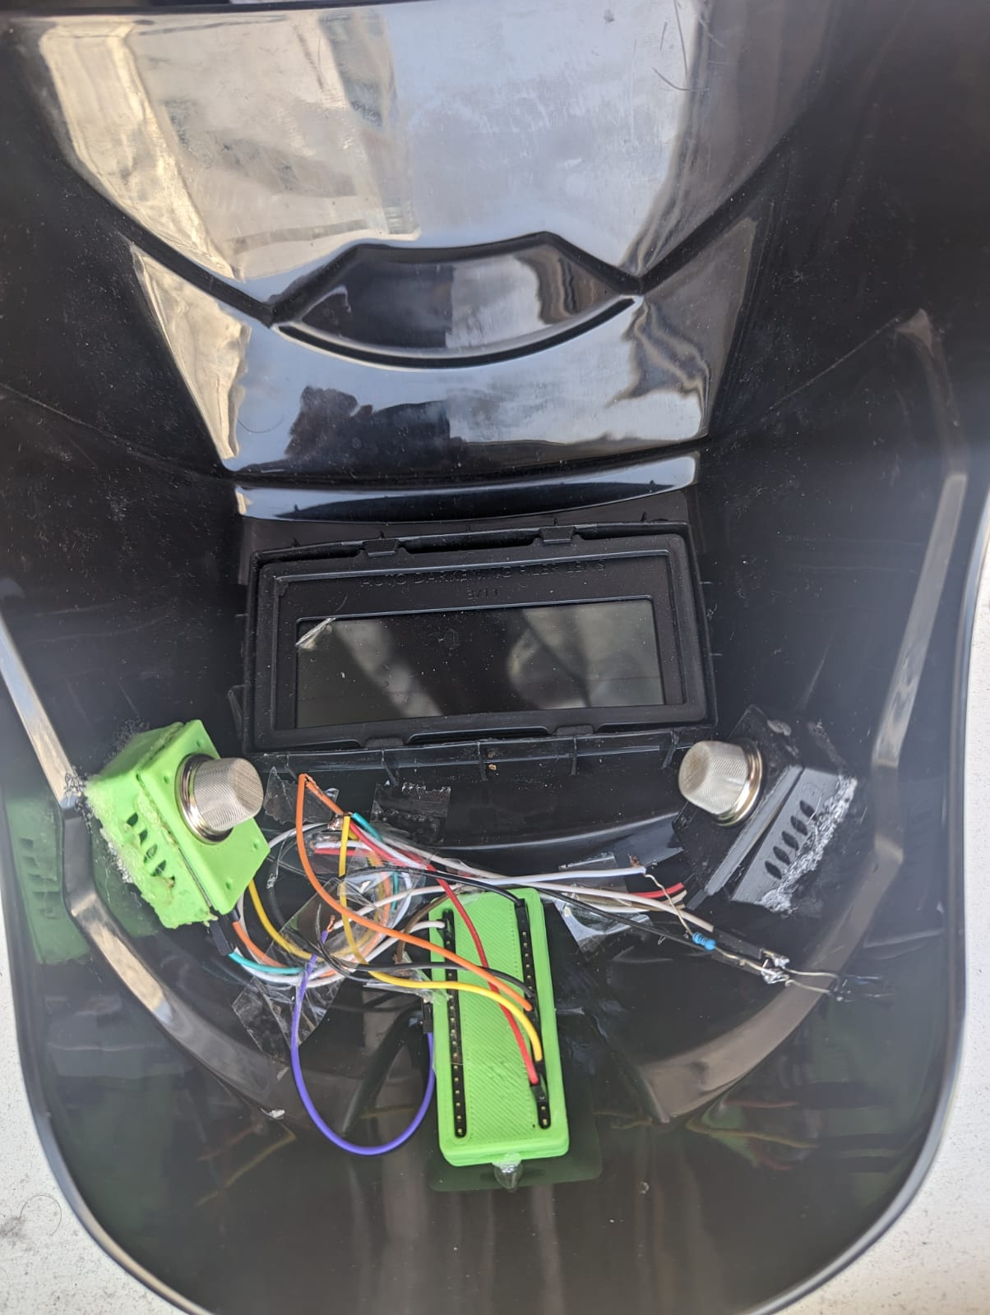
Figure 1 shows the sensors and Pico enclosed in 3d printed cases and attached to the welding helmet.
The data obtained from the sensors is transmitted to the ThingSpeak service, which serves as a platform for the analysis and visualization of data pertaining to IoT devices 4. ThingSpeak is developed by the creators of MATLAB and SIMULINK. A dedicated channel is made for the welding helmet service, where all the collected data is uploaded. Due to the utilization of the free tier of ThingSpeak, data can only be uploaded at intervals of 20 seconds. Notably, ThingSpeak offers a range of visualization options for data representation H.-P.H. (2021). The figure below illustrates the visualizations of the values captured by the TMP36 and MQ-2 sensors.
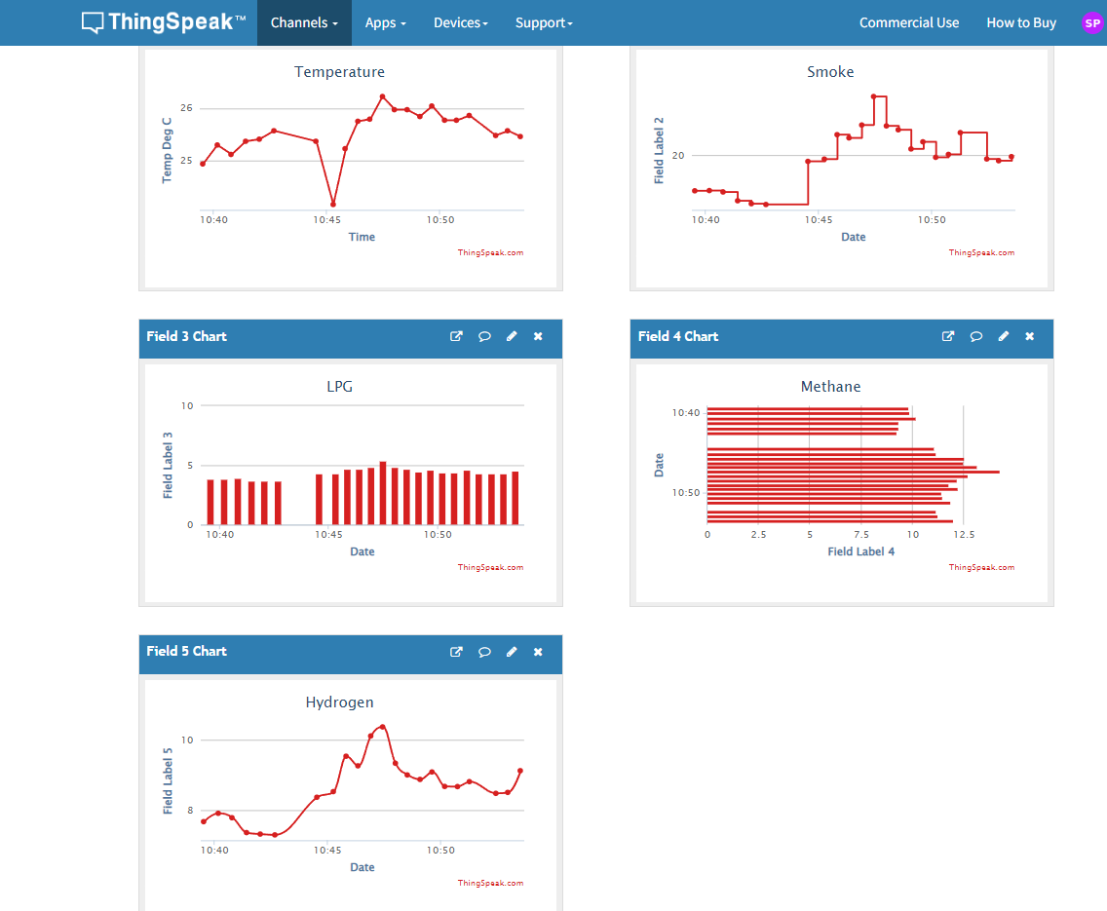
Figure 2 shows the visualisation of data in Thingspeak
Every channel has a sperate API key, the values of the sensors can be retrieved from the ThingSpeak cloud using this API key. The data of the sensors can be made available for the welder through an android app called thingshow linked to the ThingSpeak channel using the API key. A screenshot of the mobile app is show below.
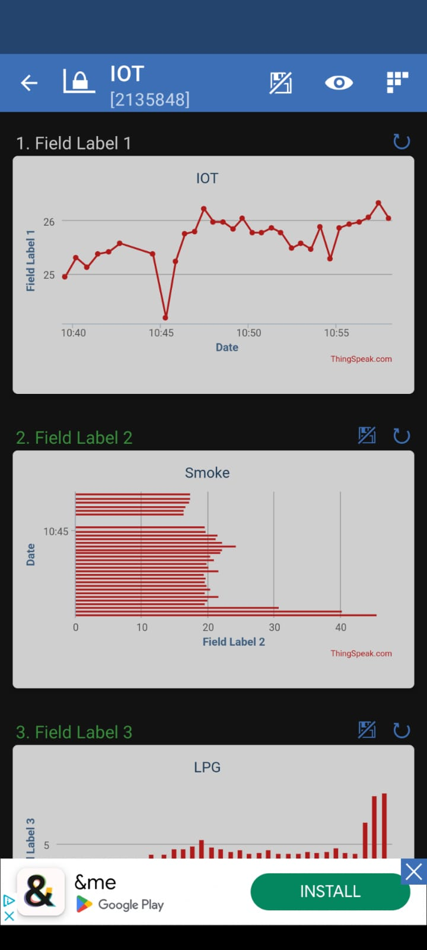
Figure 3 shows the visualisation of data in thingshow android app
The environmental conditions surrounding the welder can be remotely monitored by supervisors or safety engineers using the ThingSpeak platform through a web browser or mobile application as shown in figure 2.. To assess the air quality in the welder's vicinity, an MQ-135 sensor is employed. Whenever the air quality deteriorates below the permissible threshold, a notification is promptly dispatched to the mobile device utilizing the IFTTT service. The functionalities offered by various applications integrated within ThingSpeak are also leveraged in this context. Specifically, the combination of React and ThingHTTP eliminates the need for the microcontroller to handle the task of sending notifications to the mobile device. The React app within ThingSpeak is configured to send a request to ThingHTTP app whenever the temperature level exceed normal values, as illustrated in the figure below. Upon receiving a request from the React, ThingHTTP app sends a corresponding request is to the IFTTT service, prompting the transmission of a notification to the Android app.
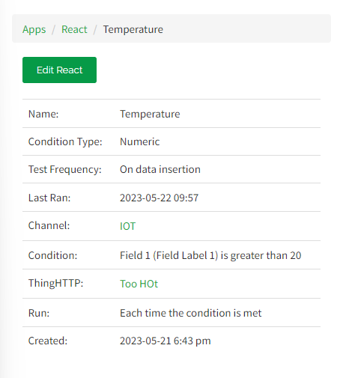
Figure 4 Cofiguration of React app in ThingSpeak
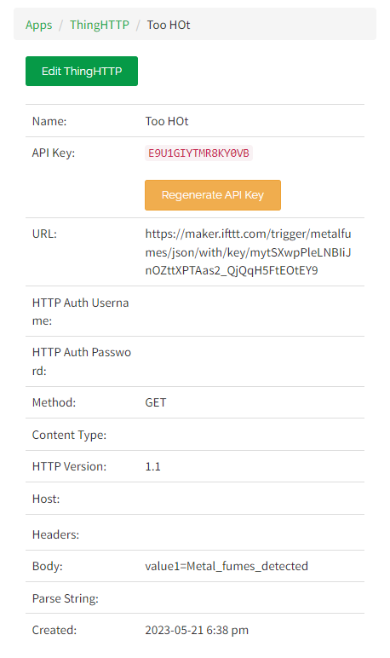
Figure 5 Configuration of ThingHTTP service in ThingSpeak

Conclusion
A smart welding helmet was successfully developed, featuring the capability of remote monitoring for temperature and pollutant levels within the surrounding atmosphere. Currently, the model relies on a computer for its power source, necessitating a tethered setup. To enhance the practicality of the helmet, there is a requirement for a battery-powered variant utilizing a Li-Po battery. However, it should be noted that the sensors employed in the current setup are relatively inexpensive and lack the precision necessary for deployment in industrial environments. As part of future improvements, the inclusion of more finely calibrated sensors could facilitate more accurate measurements without significantly escalating the overall equipment cost.
References
(www.halvorsen.blog), H.-P.H. (2021) Raspberry Pi, The Technical Guy. Available at: https://www.halvorsen.blog/documents/technology/iot/raspberry_pi_pico.php (Accessed: 22 May 2023).
Thingiverse.com (2018 a) MQ-2 sensor case by RJGII, Thingiverse. Available at: https://www.thingiverse.com/thing:2893581 (Accessed: 22 May 2023).
Thingiverse.com (2019 b) Raspberry pi pico case by GrevTech, Thingiverse. Available at: https://www.thingiverse.com/thing:4737733 (Accessed: 22 May 2023).
ThingSpeak for IOT Projects (2023) IoT Analytics - ThingSpeak Internet of Things. Available at: https://thingspeak.com/ (Accessed: 22 May 2023).

